# [Hardware](https://cs50.harvard.edu/technology/2017/notes/hardware/#hardware)

by Spencer Tiberi

## [Binary](https://cs50.harvard.edu/technology/2017/notes/hardware/#binary)

* We use computers everyday
* Inside a computer are “0s and 1s”
  + Computers use the binary number system to represent info
    - How do computers represent info with just binary?
* Consider the decimal number (what we human typically use) 123
  + The rightmost column is the 1s column
  + The middle, the 10s
  + The leftmost, the 100s

| **100** | **10** | **1** |
| --- | --- | --- |
| 1 | 2 | 3 |
|  |

* + Thus we have 100 x 1 + 10 x 2 + 1 x 3 = 100 + 20 + 3 = 123
* Inside a computer, the binary 000 would represent 0, just like in our human world!
  + However, in this case we are dealing with binary so:
    - The right most column is the 1s place
    - The middle, the 2s
    - The leftmost, the 4s

| **4** | **2** | **1** |
| --- | --- | --- |
| 0 | 0 | 0 |
|  |

* + In the human world (decimal) we use powers of 10 for place values
    - 100 = 1, 101 = 10, 102 = 100, 103 = 1000, etc.
  + In the computer world (binary) we use powers of 2 for place values
    - 20 = 1, 21 = 2, 22 = 4, 23 = 8, etc.
  + The difference between decimal numbers and binary numbers is changing the base
  + For the binary number 000, we have 4 x 0 + 2 x 0 + 1 x 0 = 0 + 0 + 0 = 0!
* Consider the binary number 001:

| **4** | **2** | **1** |
| --- | --- | --- |
| 0 | 0 | 0 |
|  |

* + We have 4 x 0 + 2 x 0 + 1 x 1 = 0 + 0 + 1 = 1
* How do we represent the decimal number 2 in binary?
  + We don’t need a 4, be we need a 2, and also no 1

| **4** | **2** | **1** |
| --- | --- | --- |
| 0 | 1 | 0 |
|  |

* + This gives us 4 x 0 + 2 x 1 + 1 x 0 = 0 + 2 + 0 = 2
* Likewise, the number 3 would be:

| **4** | **2** | **1** |
| --- | --- | --- |
| 0 | 1 | 1 |
|  |

* + As we need a 2 and a 1
  + Thus, 4 x 0 + 2 x 1 + 1 x 1 = 0 + 2 + 1 = 3
* Similarly, 4 would be:

| **4** | **2** | **1** |
| --- | --- | --- |
| 1 | 0 | 0 |
|  |

* What about 7?

| **4** | **2** | **1** |
| --- | --- | --- |
| 1 | 1 | 1 |
|  |

* + Which yields 4 x 1 + 2 x 1 + 1 x 1 = 4 + 2 + 1 = 7
* What about 8?
  + We can’t count to 8 without another bit (binary digit)
    - We run into this in the real world too if we need a four-digit number vs a 3-digit number
      * Start with the 1s, 10s, 100s place and add the 1000s
    - Here we’ll add the next power of 2, 8

| **8** | **4** | **2** | **1** |
| --- | --- | --- | --- |
| 1 | 0 | 0 | 0 |
|  |

* + - 8 x 1 + 4 x 0 + 2 x 0 + 1 x 0 = 8
* Even though computers only use binary, they can count as high as humans can!
  + They do it with a smaller vocabulary, just 1 and 0.
    - This is because it’s easier to represent two states in the physical world
      * If you think of one of these bits as being a light bulb:
        + 0 is off
        + 1 is on
      * Light bulbs just need electricity to turn on or off
      * Electricity is sufficient to turn a switch on or off
        + Inside a computer exists these switches called transistors

Modern computers have billions!

Turned off represents 0

Turned on represents 1

* Using these transistors we can store values, store data, compute, and do everything we can with computers
* David demonstrates how transistors work using light bulbs
* So far all that we can represent is numbers
  + A decision needs to be made on what pattern of 1s and 0s to represent letters, words, and paragraphs
  + All computers can store is 0s and 1s
  + To represent letters, we need a mapping of 0s and 1s to characters
    - ASCII (American Standard Code for Information Interchange) does this

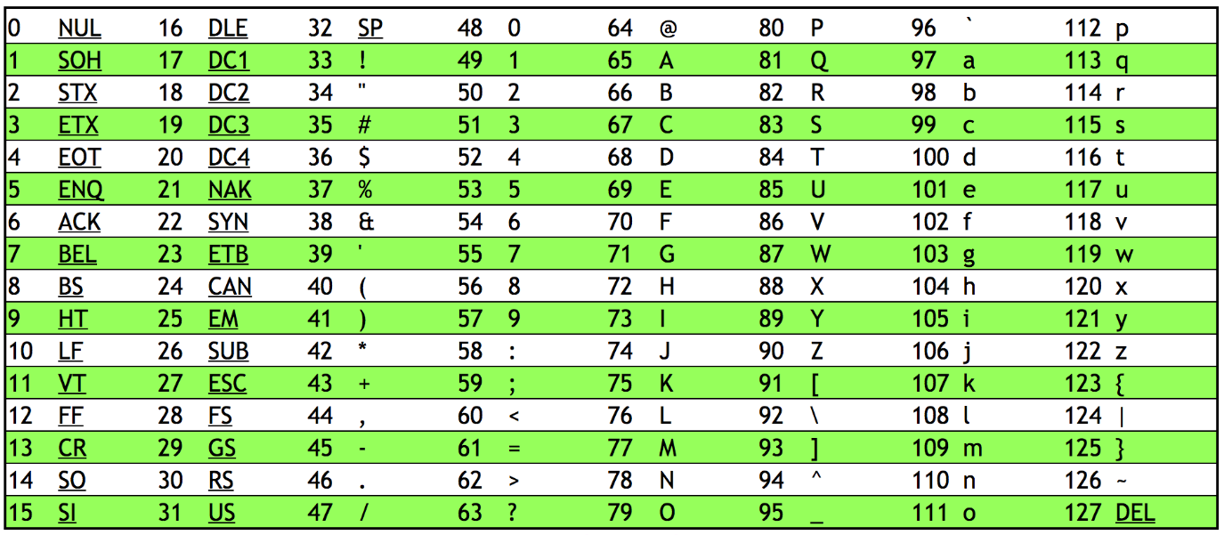

* + - 65 -> A, 66 -> B, 67 -> C, etc.
    - 97 -> a, 98 -> b, 99 -> c, etc.
    - ASCII also has mapping for punctuation symbols
  + Programs like notepad, textedit, and MicroSoft Word decide weather to display patterns of bits as letters or words
    - Computers only store 0s and 1s, but the programs interpret those bits in a certain way
      * For example, if MicroSoft word sees a pattern of buts representing the number 65, it will interpret that as “A”
  + ASCII is limited
    - Original ASCII is 7 bits, thus giving 128 characters
      * Extended ASCII is 8 bits, yielding 256 characters
    - Many symbols are not represented
  + UNICODE is a bigger set of characters that includes written languages other than English and even emoji! 😲
    - All are still represented by a pattern of bits
* Consider this pattern of bits: 01001000 01001001
  + 16 bits or 2 bytes (1 byte = 8 bits)

| **128** | **64** | **32** | **16** | **8** | | **4** | **2** | **1** |  | **128** | **64** | **32** | **16** | **8** | **4** | | **2** | **1** |
| --- | --- | --- | --- | --- | --- | --- | --- | --- | --- | --- | --- | --- | --- | --- | --- | --- | --- | --- |
| 0 | 1 | 0 | 0 | 1 | | 0 | 0 | 0 |  | 0 | 1 | 0 | 0 | 1 | 0 | | 0 | 1 |
|  |
| **1 x 64 + 1 x 8** | | | | | **1 x 64 + 1 x 8 + 1 x 1** | | | | | | | | | | |
| 72 | | | | | 73 | | | | | | | | | | |
| H | | | | | I | | | | | | | | | | |

|  |
| --- |

* + Using ASCII we get the word “HI”

## [CPU](https://cs50.harvard.edu/technology/2017/notes/hardware/#cpu)

* If you have heard that your computer has “Intel Inside,” it has an Intel processor in it

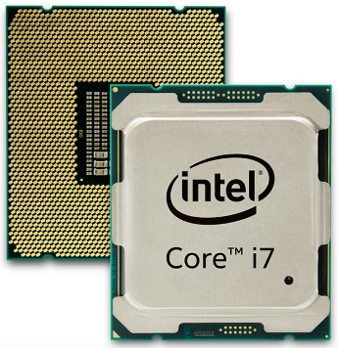

* + The backside of the processor has pins that connect into the motherboard
    - The motherboard is a circuit board made of silicon
* The CPU is the brain of the computer
  + Does all the thinking
  + Performs math in numbers fed to it
  + Helps display numbers on a screen
  + Adds or deletes numbers
* CPUs now can have multiple cores
  + Cores are the devices inside the CPU that can preform mathematical operations, load info from memory, save info to memory, etc.
  + The more cores, the more tasks a CPU can do at once
* CPUs now also support hyper-threading
  + Where a single core will present itself as multiple cores to a computer’s operating system
* Systems on a Chip (SoaC) are when a CPU and more are all interconnected at once rather than attached to a motherboard
  + Popular in phones, tables, and game consoles
  + Raspberry Pi

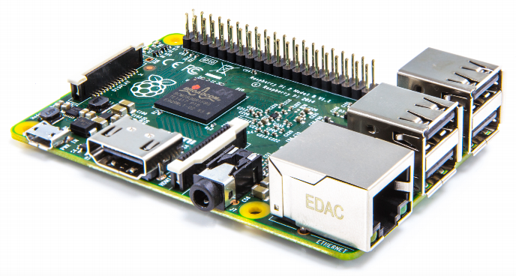

## [RAM (Random Access Memory)](https://cs50.harvard.edu/technology/2017/notes/hardware/#ram-random-access-memory)

* Circuit board with chips that slides into a slot on the motherboard

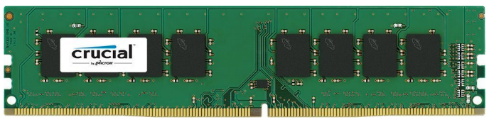

* + The chips store data
    - Only stores data when the power is on
  + Files and programs are loaded onto these chips when ran
  + Fast memory
* You can check your RAM and other specs:
  + Windows Task Manager

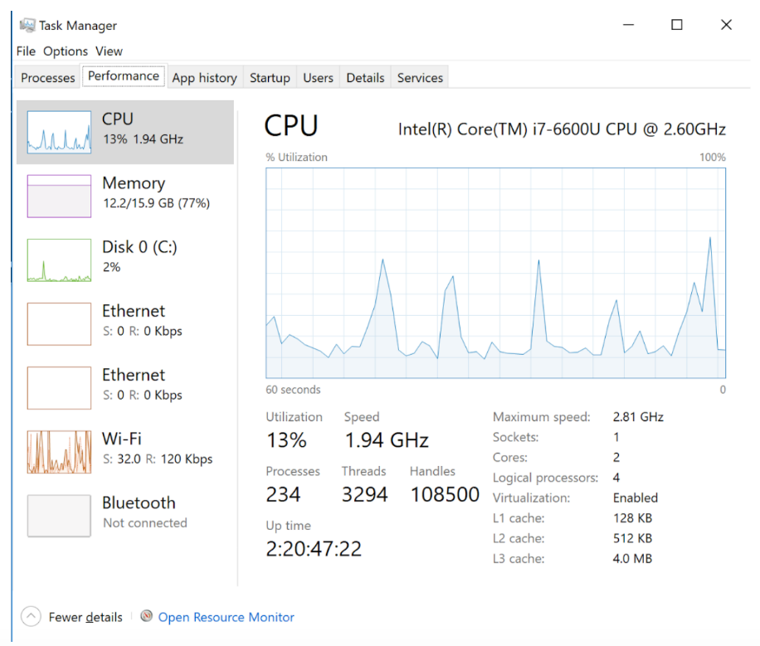

* + - CPU chart shows when peak usage occurs
    - GHz is the number of operations a CPU can perform per second (in billions)
      * 1.94 GHz = 1.94 billion operations per second
    - Logical processors in this case is 4, which means both cores support hyper-threading
      * Each core will do two things at once as if 4 cores exist
  + Mac System Profiler

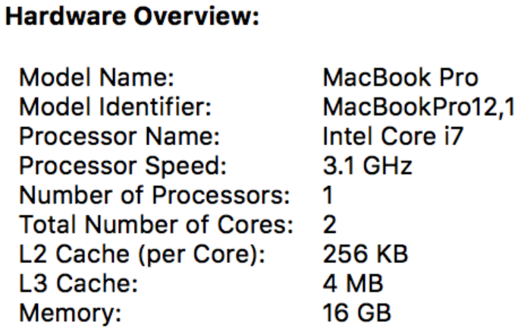

## [Hard Drives](https://cs50.harvard.edu/technology/2017/notes/hardware/#hard-drives)

* When you turn a computer off, you need a place to store data
  + A hard disk drive (HDD) stores this information

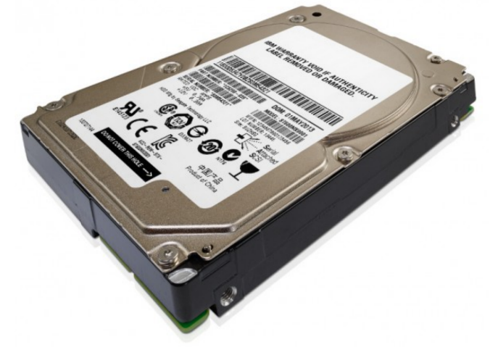

* + RAM may store 1 GB, 2 GB, 4 GB, through 16 GB or so
  + HDD stores 256 GB, 1024 GB (AKA terabyte or TB), 2 TB
  + Inside a HDD, metal platters physically spin around

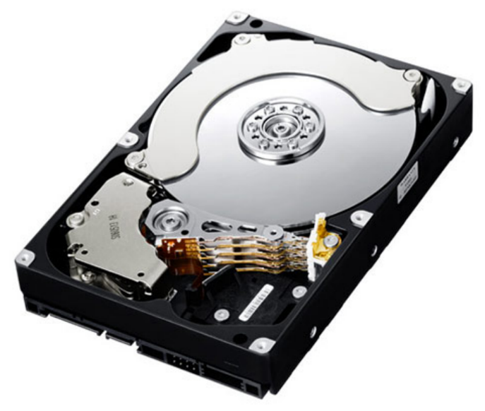

* + - Data is stored on these disks
    - The reading heads move back and forth reading data from the device
    - Uses tiny magnetic particles where north pole orientation represents 1 and south pole orientation represents 0
      * Power is only needed to read or change the data
        + Data is preserved when power is off
    - David shows a video of a HDD running in slowmo
* To store data in a hard drive, RAM sends data and instructions to the HDD
  + The hard drive translates that data into voltage fluctuations
    - Some signals spin the platters, others move the read/write heads
    - Pulses sent to the read/write head turn on a magnet which creates a field that changes the polarity of a tiny portion of the metal platter’s surface
    - Power is sent in different directions as to change polarity
  + To read, the particles on the disk use their charge to move the read/write head.
  + Pieces of a file can be spread out around the platters
    - A special file keeps track of data’s location
  + Anytime you have a physical device that moves over a period of time, things go wrong
    - Dropping a HDD can corrupt files
  + Platters spin slower than how fast electrons move

## [Flash Memory](https://cs50.harvard.edu/technology/2017/notes/hardware/#flash-memory)

* Solid state disk (SSD)

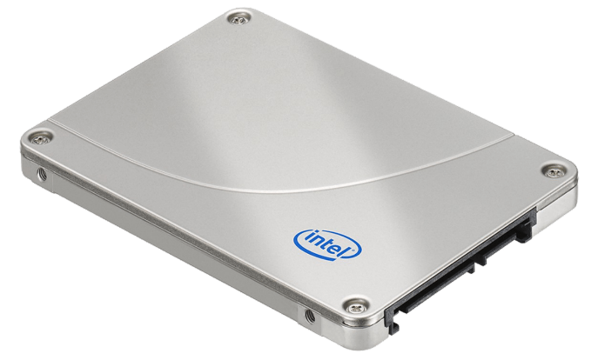

* + Smaller (3.5 inch width for HDD vs 2.5 inch width for SSD)
    - Still fits where old HDDs are
  + No moving particles
  + Inside, it looks a lot like RAM

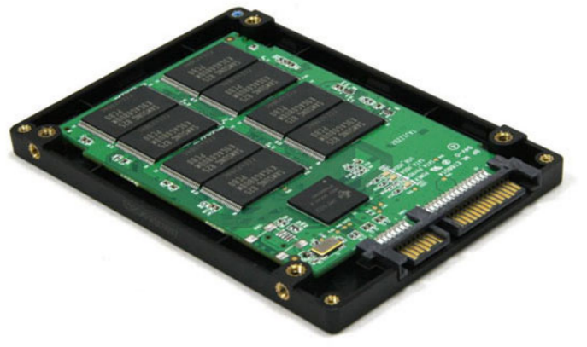

* + Much faster than HDD
    - Programs/files load and save more quickly
  + SSD theoretically don’t last as long as HDD
    - Finite number of writes
* Hybrid Drives
  + Some GB of solid state memory and more GB or TB of HDD space
  + Stores as much of frequently-needed data on the SSD
  + Stores less frequently-needed data on HDD
* Flash memory also exists in the form of USB sticks
  + Might store 1 GB, 16 GB, or more
  + Portable
* External SSDs exist for more storage
  + Might store 256 GB or more
  + Can be used to share data with others without network usage
* Can also have external HDD

## [Types of Memory and Funneling](https://cs50.harvard.edu/technology/2017/notes/hardware/#types-of-memory-and-funneling)

* There is a tradeoff between space, money, and speed of data transfer



* + Data is pushed “down the funnel” to your CPU
    - From the hard drive, data first goes to the RAM

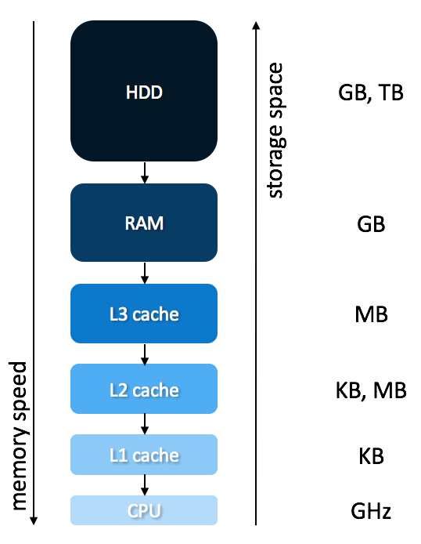

* + - Theoretically, the CPU never has to wait for data to crunch
    - There is a tiny amount of memory (bytes) called registers where numbers are stored for operations.
    - Memory at the bottom is more expensive
    - Disk is important for the long-term storage
    - RAM is important as it stores programs you use simultaneously
    - L3, L2, L1 cache are on the motherboard
* As an analogy for memory, picture a candy store
  + A customer approaches the counter and requests candy
  + The shop owner then leaves the counter to grab the candy before returning moments later
    - Not super efficient to walk all the way to the store room to grab candy
      * Better to have a cache of memory
  + Instead, the shop owner leaves the counter to ready a cache of candy before the customers arrive
  + When a customer comes, the candy can be distributed quickly
    - Cache memory similarly helps the CPU in this manner
* We can see sizes of cache looking at computer specs like before

## [Display Connectors](https://cs50.harvard.edu/technology/2017/notes/hardware/#display-connectors)

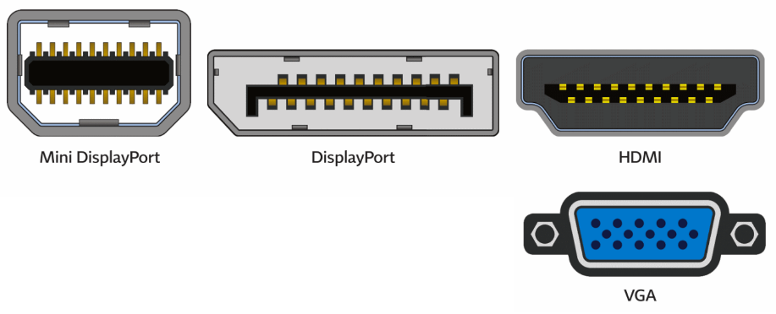

* These sockets all connect to monitors or displays
* Mini DisplayPort are used form monitors
* HDMI is not only on laptops and computers but also TVs
* VGA is older, but still commonly uses on projectors

## [USB (Universal Serial Bus)](https://cs50.harvard.edu/technology/2017/notes/hardware/#usb-universal-serial-bus)

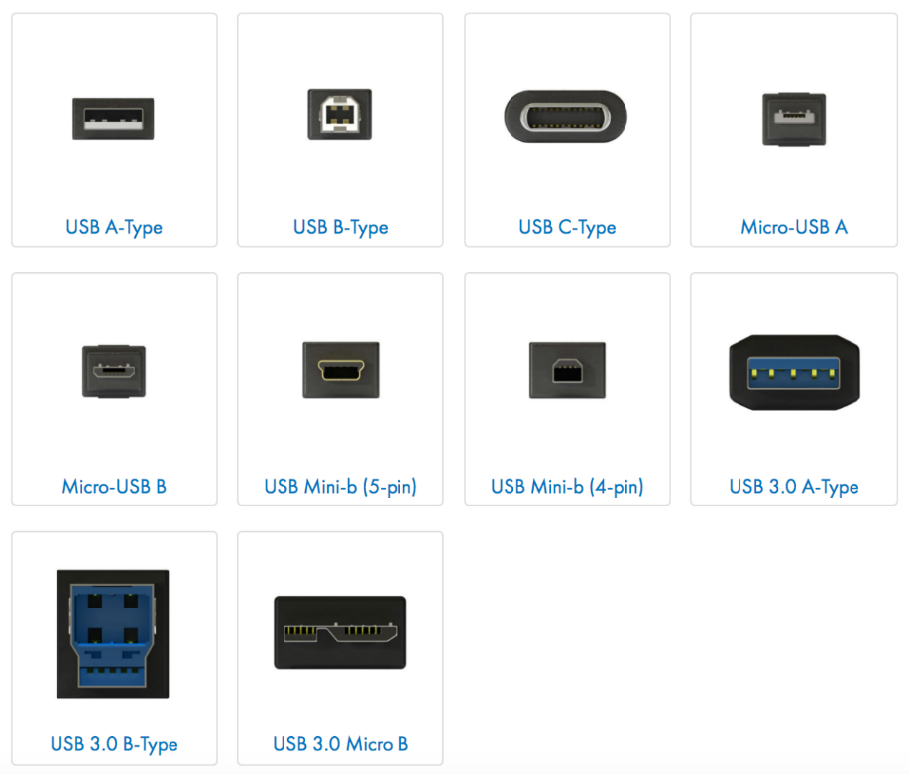

* Can plug in a whole range of peripheral devices including printers, keyboards, mice, scanners, etc.
* USB-A most common
* USB-B is often used for printers and scanners
* USB-C is newer and can be plugged in coming from different directions
* Other variants often exist for phones
* Older USB connections are slower when transferring data
  + Hard drives can connect via USB
    - Even if a hard drive is fast, if the USB is slow, the transfer of data will be slow

## [Wireless](https://cs50.harvard.edu/technology/2017/notes/hardware/#wireless)

* Wifi is wireless internet
* Bluetooth allows devices such as wireless keyboards and headphones to connect to your computer
  + Limited range
    - This is ok as it is used for you to connect to your own device

## [Operating System (OS)](https://cs50.harvard.edu/technology/2017/notes/hardware/#operating-system-os)

* Software that ensures all devices work and can intercommunicate
* MacOS and Windows are popular OS
* Can be installed by the user, but is typically done so by a manufacturer
  + Installed on HDD or SDD so that it exists persistently without power
* When you hit power on your computer, the OS is loaded into RAM
* Gives you the graphical interface that you see
* Knows how to:
  + Talk to your keyboard and mouse
  + Display info on the screen
  + Move things around in memory
* This is all thanks to device drivers installed with the OS
  + Special software designed to talk to certain model of printer, camera, scanner, etc.
* When an OS doesn’t recognize a device, perhaps because it’s too new, you can download new device drives from the device manufacturer
  + Teaches Window, MacOS, or Linux about that new hardware
  + Future-proofing structure
* It’s this intersection of hardware and software that makes computers powerful!

## [Looking Underneath the Hood](https://cs50.harvard.edu/technology/2017/notes/hardware/#looking-underneath-the-hood)

* David and Colton Ogden look at the exterior of an old ThinkPad computer, examining ports
  + Power bricks convert power from the wall into safe amounts for the computer
* David and Colton examine the inside of an old window desktop, highlighting the motherboard, heatsink, RAM, Hard Drive, etc.
* David and Colton then look inside a HDD
  + Once exposed to air and dust, it’s no longer reliable enough to use
* David and Colton then look at a motherboard examining all the ports on it